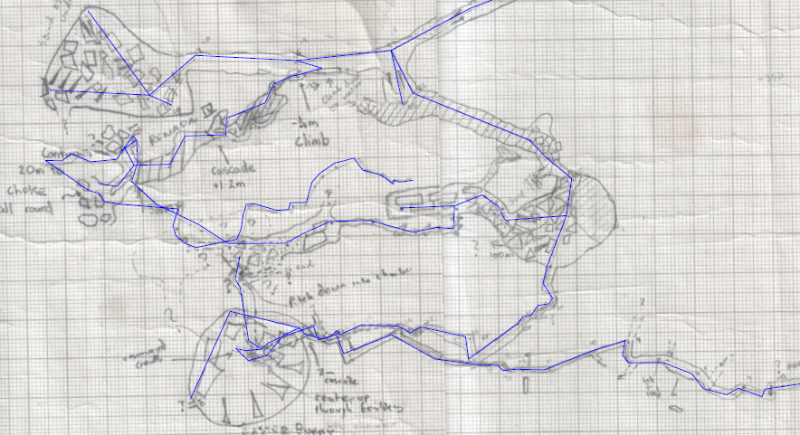
8m above – no connection made to chamber
4m above – no connection made to chamber
Passages from lake area are some 10+m above sump and choke below – seem not to have been drawn up

